

MGM University
Dr. G. Y. Patrikar College of Computer Science &
Information Technology,
N-6, Cidco, Chhatrapati Sambhajinagar

FINAL PROJECT REPORT
ON
“ Devine Vibes”

Submitted By:
Gaurav Kulkarni - B0231007
Rutuja Kulkarni- B0231027
Megha Bachate - B0231013

COURSE B.Sc.-IT (hons) IInd year. IVth Sem.
Guided By:
Ms. Pratibha Ratnamala Bhise

MGM University
Dr. G. Y. Pathrikar College of Computer Science &
Information Technology,
N-6, Cidco, Chhatrapati Sambhajinagar

CERTIFICATE

This is to certify that Mr. /Miss. Bhakti kulkarni has Contributed in successfully completing the Project of “Bootstrap” as a partial fulfillment of the course B.Sc.-IT (hons) IInd year. IVth Sem Under the guidance of Ms. Pratibha Ratnamala Bhise Mam during the Academic year 2024-2025
Roll No: B0231035
Exam Date:

Ms. Pratibha Ratnamala Bhise Dr. Satish Sankaye
Project Guide Head of Department

MGM University
Dr. G. Y. Pathrikar College of Computer Science &
Information Technology,
N-6, Cidco, Chhatrapati Sambhajinagar

CERTIFICATE

This is to certify that Mr. /Miss. Rutuja kulkarni has Contributed in successfully completing the Project of “Bootstrap” as a partial fulfillment of the course B.Sc.-IT (hons) IInd year. IVth Sem Under the guidance of Ms. Pratibha Ratnamala Bhise Mam during the Academic year 2024-2025
Roll No: B0231039
Exam Date:

Ms. Pratibha Ratnamala Bhise Dr. Satish Sankaye
Project Guide Head of Department

MGM University
Dr. G. Y. Pathrikar College of Computer Science &
Information Technology,
N-6, Cidco, Chhatrapati Sambhajinagar

CERTIFICATE

This is to certify that Mr. /Miss. Megha bachate has Contributed in successfully completing the Project of “Bootstrap” as a partial fulfillment of the course B.Sc.-IT (hons) IInd year. IVth Sem Under the guidance of Ms. Pratibha Ratnamala Bhise Mam during the Academic year 2024-2025
Roll No: B0231046
Exam Date:

Ms. Pratibha Ratnamala Bhise Dr. Satish Sankaye
Project Guide Head of Department

1.ACKNOWLEDGEMENT :

We would like to express our sincere gratitude to the Head of Department, Dr. Satish Sankaye, for providing us with the opportunity and guidance to carry out our project titled “Bootstrap Travel Blog.”

We are especially thankful to our project guide, Miss. Pratibha Ratnamala Bhise, for her continuous support, valuable suggestions, and encouragement throughout the development of this project.

We also acknowledge the support of our group members — Bhakti kulkarni,Rutuja kulkarnu, and Megha Bachate — for their collaboration and active contribution in completing this work successfully.B.Sc. IT (Hons.) – 2nd Year, 4th Semester

2. ABSTRACT :

The project titled “Bootstrap Travel Blog” is a responsive and visually appealing website developed using HTML, CSS, JavaScript, and the Bootstrap framework. It is designed to present travel experiences, tips, and images in a structured and engaging format.

This project demonstrates how Bootstrap helps in building mobile-friendly and consistent layouts efficiently. It includes sections such as travel destinations, gallery, contact form, and blog content, showcasing the effective use of front-end web technologies.

TABLE OF CONTENTS
1.ACKNOWLEDGEMENT : 1
2. ABSTRACT : 1
• INTRODUCTION TO BOOTSTRAP 3
- • CORE COMPONENTS OF BOOTSTRAP : 3
3.PROJECT OBJECTIVE : 4
4.PLATFORM USED : 4
5.FEATURES OF BOOTSTRAP TRAVEL BLOG : 5
6.Design Of Project 6
7.Implementation 8
8.LIMITATION OF CURRENT SYSTEM 11
• CONCLUSION : 11
9. REFERENCES : 12
10-.TEAM CONTRIBUTION AND TASK ALLOCATION : 12

PROJECT ON TRAVEL BLOG WEBSITE

INTRODUCTION TO BOOTSTRAP

Bootstrap is a popular open-source front-end framework developed by Twitter for creating responsive and mobile-first websites. It combines HTML, CSS, and JavaScript to help developers design web pages quickly and efficient

The framework offers a flexible grid system that automatically adapts to different screen sizes, making websites compatible across desktops, tablets, and smartphones. Bootstrap also provides a wide range of pre-designed components like buttons, forms, navigation bars, modals, and carousels, which help maintain consistency and reduce development time.

By using Bootstrap, developers can build visually appealing and user-friendly websites without writing much custom code, making it an ideal tool for modern web development.

CORE COMPONENTS OF BOOTSTRAP :

Bootstrap includes several essential components that simplify and speed up web development:

1. Grid System – A responsive 12-column layout that helps structure content across different screen sizes.
2. Forms – Built-in styles for input fields, checkboxes, radio buttons, and validations to create clean and functional forms.
3. Buttons – Predefined button styles in various sizes and colors used for user interactions.
4. Navbar – A responsive navigation bar that can collapse or expand based on screen size.
5. Cards – Flexible containers to display content, combining text, images, headers, and footers.
6. Alerts – Color-coded messages used to show success, warning, or error notifications.
7. Modals – Popup windows to display content like forms or messages without redirecting the page.
8. Carousel – A slideshow component for rotating banners, images, or text content.
9. Utilities – Helper classes that manage spacing, colors, alignment, visibility, and more.
These components make it easier to build modern, responsive, and visually appealing websites with minimal effort.

3.PROJECT OBJECTIVE :

The main objective of the project “Bootstrap Travel Blog” is to design and develop a responsive and visually engaging blog website using Bootstrap. The blog aims to serve as a platform for travelers to:

- Share their travel experiences through articles and photos.

- Provide useful travel tips and suggestions to readers.

- Highlight popular destinations and travel itineraries.

- Encourage community interaction through contact forms or feedback.

This project also aims to showcase the power of Bootstrap in simplifying front-end development and building responsive layouts without the need for complex CSS or JavaScript code.

4.PLATFORM USED :

The following platforms, tools, and technologies were used in the development of the “Bootstrap Travel Blog” project:

Frontend Technologies:

- HTML5
- CSS3
- JavaScript
- Bootstrap 5

Development Tools:
- Visual Studio Code

Browser for Testing:

- Google Chrome
- Mozilla Firefox

Operating System:

- Windows 10

These platforms were selected for their ease of use, availability, and efficiency in developing responsive web applications.

5.FEATURES OF BOOTSTRAP TRAVEL BLOG :

Technologies Used: HTML5, CSS, Bootstrap 5.3

Navbar: Responsive, includes links to Home, Destinations, and Contact

Hero Section: Gradient heading and subheading with vibrant text

Destinations Section:

- 3 cards for Paris, Disneyland, and Singapore
- Each with image, title, and short description

Contact Form: Fields for name, email, and message with a submit button

Footer: Simple dark footer with copyright

Design: Gradient backgrounds, colorful text, and clean layout

6.Design Of Project

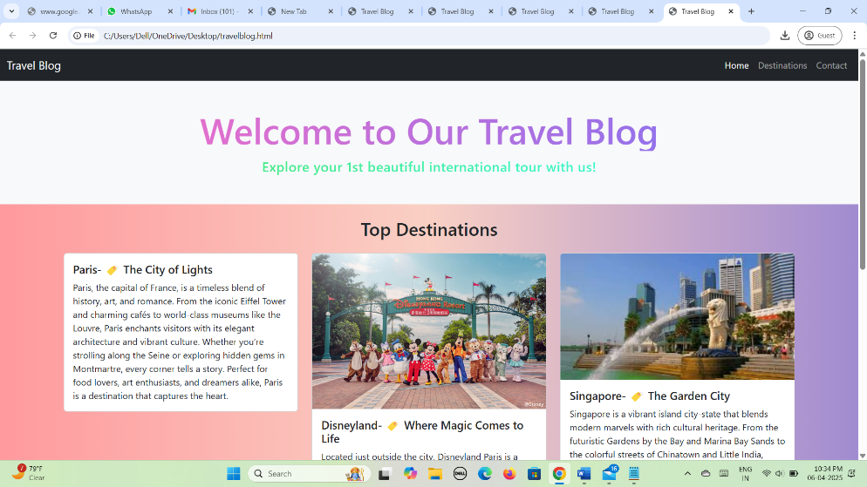

Homepage Display :

Destination Section

- Purpose: Displays the top travel destinations on the website.

Details:

- Heading: "Top Destinations" with center alignment.

- Card Layout: Three destination cards using Bootstrap grid system (col-md-4 each).

- Images: Used real images for Paris, Disneyland, and Singapore to visually represent each location.

- Titles and Subtitles: Each card contains a location name and a short tagline (e.g., "Paris – The City of Lights").

- Descriptions: Provided short, engaging paragraphs describing highlights of each destination to attract travel
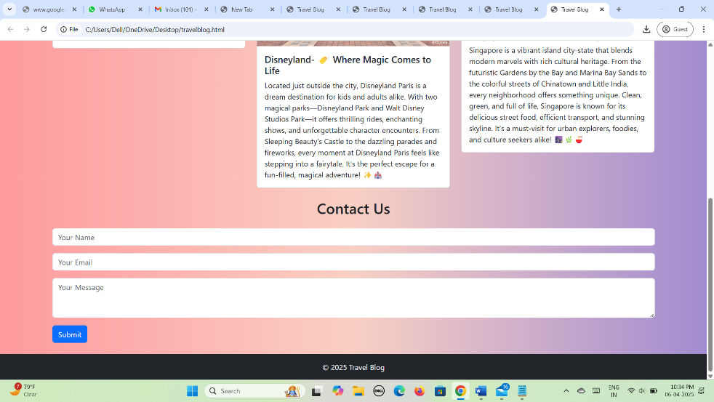

Contact Section

- Purpose: Allows visitors to reach out via a contact form.

Details:

- Heading: "Contact Us" aligned to the center.

- Form Elements: Includes fields for Name, Email, and Message using Bootstrap's form-control.

- Design: Clean and minimal with proper spacing (mb-3) between fields.

- Submit Button: A btn btn-primary used for submitting the form, placed directly after the message field.

7.Implementation
<!DOCTYPE html>
<html lang="en">
<head>
<meta charset="UTF-8">
<meta name="viewport" content="width=device-width, initial-scale=1.0">
<title>Portfolio Website</title>
<link href="https://cdn.jsdelivr.net/npm/bootstrap@5.3.0/dist/css/bootstrap.min.css" rel="stylesheet">
</head>
<body>
<!-- Navbar -->
<nav class="navbar navbar-expand-lg navbar-dark bg-dark">
<div class="container">
<a class="navbar-brand" href="#">My Portfolio</a>
<button class="navbar-toggler" type="button" data-bs-toggle="collapse" data-bs-target="#navbarNav">
<span class="navbar-toggler-icon"></span>
</button>
<div class="collapse navbar-collapse" id="navbarNav">
<ul class="navbar-nav ms-auto">
<li class="nav-item"><a class="nav-link" href="#about">About</a></li>
<li class="nav-item"><a class="nav-link" href="#projects">Projects</a></li>
<li class="nav-item"><a class="nav-link" href="#contact">Contact</a></li>
</ul>
</div>
</div>
</nav>

<!-- Hero Section -->
<header class="bg-primary text-white text-center py-5">
<h1>Welcome to My Portfolio</h1>
<p>Web Developer | Designer | Coder</p>
</header>

<!-- About Section -->
<section id="about" class="container py-5">
<h2 class="text-center">About Me</h2>
<p class="text-center">I am a passionate web developer with expertise in front-end technologies.</p>
</section>

<!-- Projects Section -->
<section id="projects" class="bg-light py-5">
<div class="container">
<h2 class="text-center">My Projects</h2>
<div class="row text-center">
<div class="col-md-4">
<div class="card">
<img src="https://via.placeholder.com/300" class="card-img-top" alt="Project 1">
<div class="card-body">
<h5 class="card-title">Project One</h5>
<p class="card-text">Description of project one.</p>
</div>
</div>
</div>
<div class="col-md-4">
<div class="card">
<img src="https://via.placeholder.com/300" class="card-img-top" alt="Project 2">
<div class="card-body">
<h5 class="card-title">Project Two</h5>
<p class="card-text">Description of project two.</p>
</div>
</div>
</div>
<div class="col-md-4">
<div class="card">
<img src="https://via.placeholder.com/300" class="card-img-top" alt="Project 3">
<div class="card-body">
<h5 class="card-title">Project Three</h5>
<p class="card-text">Description of project three.</p>
</div>
</div>
</div>
</div>
</div>
</section>

<!-- Contact Section -->
<section id="contact" class="container py-5">
<h2 class="text-center">Contact Me</h2>
<form>
<div class="mb-3">
<label class="form-label">Your Name</label>
<input type="text" class="form-control" placeholder="Enter your name">
</div>
<div class="mb-3">
<label class="form-label">Email Address</label>
<input type="email" class="form-control" placeholder="Enter your email">
</div>
<div class="mb-3">
<label class="form-label">Message</label>
<textarea class="form-control" rows="4" placeholder="Your message"></textarea>
</div>
<button type="submit" class="btn btn-primary">Send Message</button>
</form>
</section>

<!-- Footer -->
<footer class="bg-dark text-white text-center py-3">
<p>&copy; 2025 My Portfolio. All Rights Reserved.</p>
</footer>

<script src="https://cdn.jsdelivr.net/npm/bootstrap@5.3.0/dist/js/bootstrap.bundle.min.js"></script>
</body>
</html>

8.LIMITATION OF CURRENT SYSTEM

The current system lacks interactivity and dynamic features like real-time user feedback or integrated search filters for destinations.

- Images used are stored locally, which may lead to display issues if the file path is incorrect or not supported across different systems.

- There is no backend connectivity; the contact form does not process or store submitted user data.

- The website is static and not optimized for content management or scalability.

- Accessibility features and SEO optimizations are missing, limiting usability and online visibility.

CONCLUSION :

This Bootstrap project successfully covered key steps from setting up the HTML structure to implementing responsive design elements. Bootstrap CDN integration, navigation bar, carousel, and grid layout were effectively utilized to ensure a mobile-friendly and visually structured website. Custom sections and utility classes enhanced both the appearance and functionality. the project improved my practical skills in front-end development, especially in responsive design, component usage, and layout customization using Bootstrap.

9. REFERENCES :

- W3Schools. (n.d.). HTML, CSS, JavaScript Tutorials. Retrieved from https://www.w3schools.com

- GeeksforGeeks. (n.d.). Web Development Basics. Retrieved from https://www.geeksforgeeks.org

- MDN Web Docs. (n.d.). Web Technology Documentation. Retrieved from https://developer.mozilla.org

- Code snippets and layout design concepts referred from free online HTML/CSS resources and templates.

- Screenshots and content collected during website creation and practical implementation of the project.

10-.TEAM CONTRIBUTION AND TASK ALLOCATION :

The project was completed through collaborative efforts. Each member was assigned a specific role to ensure smooth execution and timely submission of the project. The tasks were divided as follows:

1. Bhakti kulkarni:

- Drafted and compiled the entire project report.

- Wrote key sections: Abstract, Introduction, Objectives, Platform Details, Features, Limitations, Conclusion.

- Ensured formatting guidelines and structure were followed properly.

2. Rutuja kulkarni

- Developed the complete Bootstrap-based website.

- Created and designed web pages (Home, About, Contact, etc.).

- Handled layout, styling, and responsiveness using HTML, CSS, and Bootstrap.

3. Megha bachate :

- Prepared all required certificates and title page

- Created: College Certificate, Guide Certificate, Project Completion Letter.

- Ensured proper formatting and details as per academic requirements.

4.Collaborative Tasks :

- Participated in initial planning, brainstorming, and discussions.

- Reviewed each other’s work for accuracy, consistency, and completeness.

- Maintained regular communication to stay on track and meet deadlines.

